EXPT NO: 7 | TEXT PREPROCESSING AND EMBEDDING GENERATION USING NLP LIBRARIES
DATE: 11-10-26

PRE-LAB QUESTIONS

1. Explain the importance of text preprocessing in Natural Language Processing.

Text preprocessing is an important step in Natural Language Processing (NLP) that converts raw text into a clean and structured format. It involves removing unnecessary characters, converting text to lowercase, tokenization, stop-word removal, and lemmatization. These techniques reduce noise and improve the quality of textual data. Preprocessing helps NLP models understand the text more effectively. It also improves the efficiency and accuracy of various language processing tasks.

2. Differentiate between tokenization, stemming and lemmatization.

Tokenization is the process of splitting text into smaller units called tokens, such as words or sentences. Stemming reduces words to their root form by removing prefixes or suffixes, which may produce incomplete words. Lemmatization converts words into their meaningful dictionary base forms using linguistic rules. For example, stemming may convert “studies” into “studi,” while lemmatization converts it into “study.” All three techniques help simplify text for NLP applications.

3. Explain the purpose of stop-word removal in text preprocessing.

Stop-word removal is the process of eliminating frequently occurring words that often carry little useful information for a particular NLP task. Examples include “the,” “is,” “and,” and “of.” Removing these words reduces the size of the text and decreases unnecessary computational work. It helps focus on more meaningful words during text analysis. However, stop-word removal should be applied carefully because some common words may be important for understanding context and meaning.

4. Describe word embeddings and their significance in deep learning.

Word embeddings are numerical vector representations of words that capture their semantic and contextual relationships. They convert textual data into dense numerical representations that deep learning models can process. Words with similar meanings or usage often have similar vector representations. Embeddings help models identify relationships between words and understand patterns in language. They are widely used in applications such as sentiment analysis, machine translation, text classification, and question answering.

5. Explain how Word2Vec represents words as dense numerical vectors.

Word2Vec is a word embedding technique that learns numerical representations of words from their surrounding context in a text corpus. It uses two architectures called Continuous Bag of Words (CBOW) and Skip-gram. These architectures learn word relationships by predicting a target word from its context or predicting surrounding words from a target word. Each word is represented by a dense vector containing a fixed number of numerical values. Words that appear in similar contexts generally obtain similar vector representations.

AIM
To perform text preprocessing using NLTK and generate word embeddings using Gensim Word2Vec to analyze semantic relationships between words.

SOFTWARE REQUIREMENTS
- Python
- NLTK
- Gensim
- NumPy
- Google Colab
- GitHub

OBJECTIVES
Students will be able to:
- Understand the architecture and working of Recurrent Neural Networks (RNNs).
- Perform text preprocessing techniques for sequence modeling.
- Generate input sequences suitable for training an RNN model.
- Build and train an RNN model for text generation.
- Generate text by predicting the next word in a sequence.
- Evaluate the performance of the trained RNN using generated text.
- Analyze the effectiveness of RNNs in learning sequential patterns from textual data.

PROCEDURE
PART A: DATASET PREPARATION AND TEXT PREPROCESSING
Perform the following tasks:
- Load the Brown Corpus available in NLTK and select a suitable text category.
- Examine sample sentences from the selected dataset.
- Convert the text into lowercase.
- Perform word tokenization using NLTK.
- Remove punctuation and stop words.
- Perform lemmatization using WordNetLemmatizer.
- Display the original and preprocessed text.

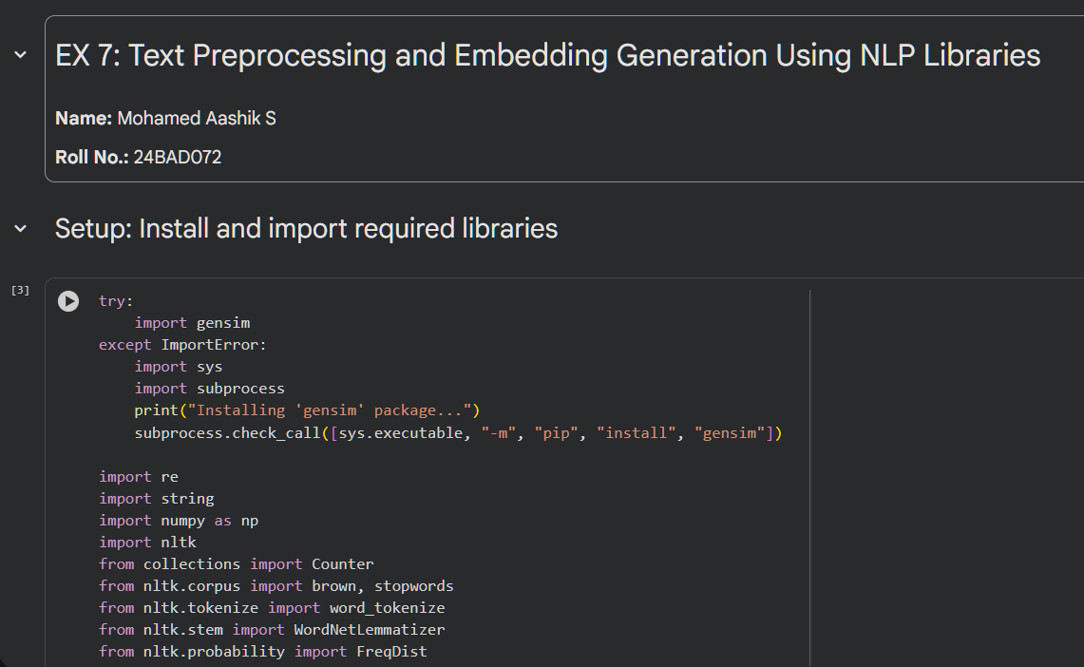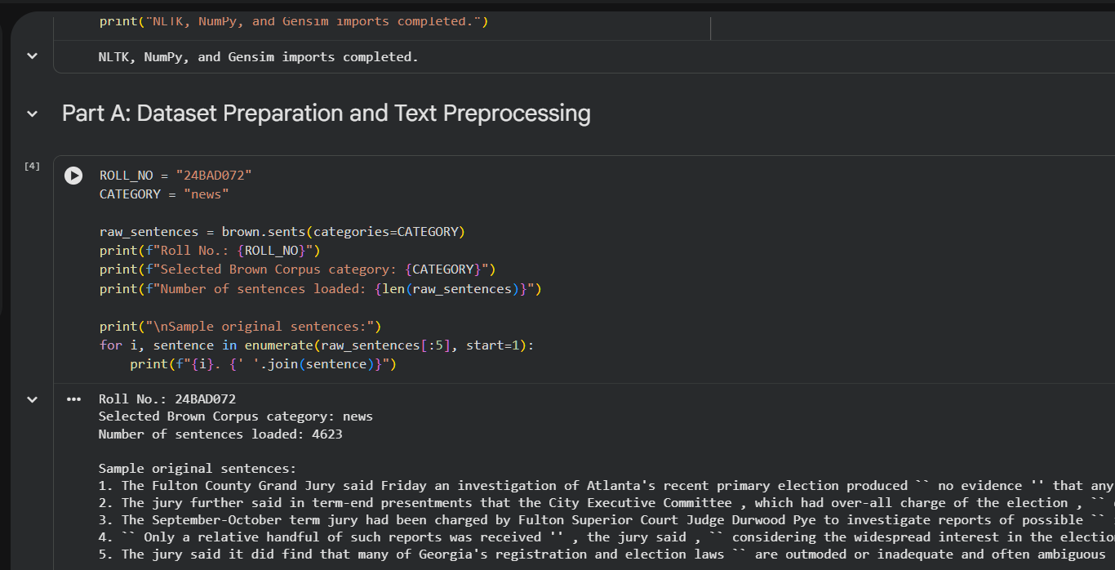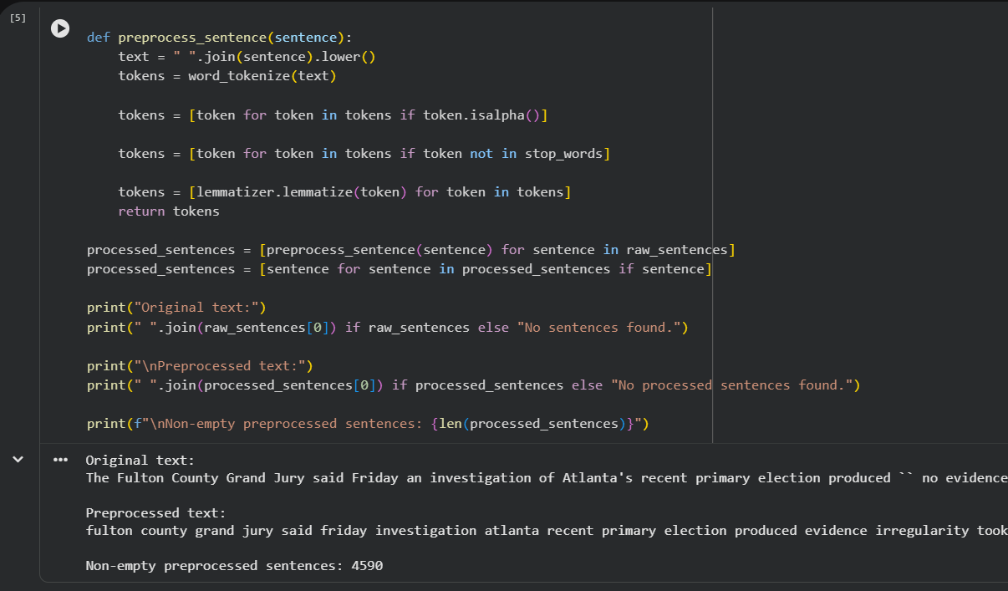

PART B: VOCABULARY GENERATION AND WORD FREQUENCY ANALYSIS
Perform the following tasks:
- Create a vocabulary from the preprocessed text.
- Calculate word frequencies using NLTK's FreqDist.
- Identify the ten most frequently occurring words.
- Display the vocabulary size and frequency distribution.
- Prepare the tokenized sentences for Word2Vec training.

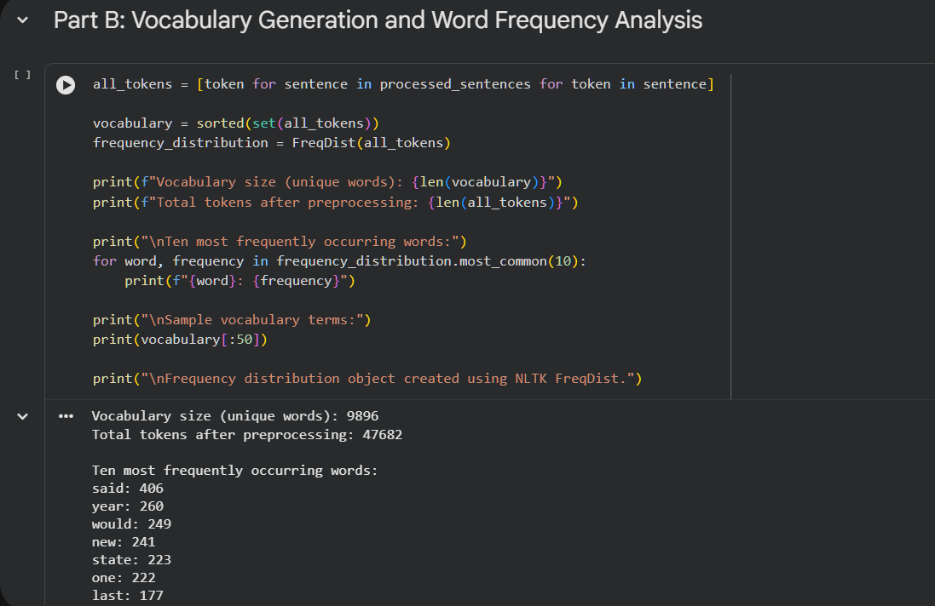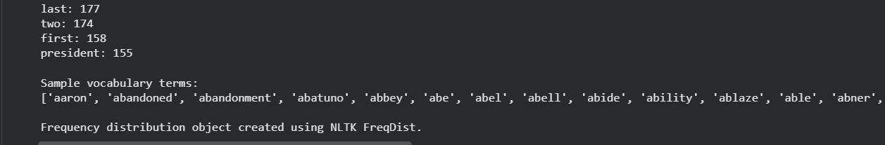

PART C: WORD EMBEDDING GENERATION USING WORD2VEC
Perform the following tasks:
- Train a Word2Vec model using Gensim on the preprocessed sentences.
- Use the Skip-gram architecture with an embedding dimension of 100 and a context-window size of 5.
- Generate embedding vectors for selected words.
- Display the embedding vector and its dimensions.
- Identify the five most similar words for a selected word using the trained model.

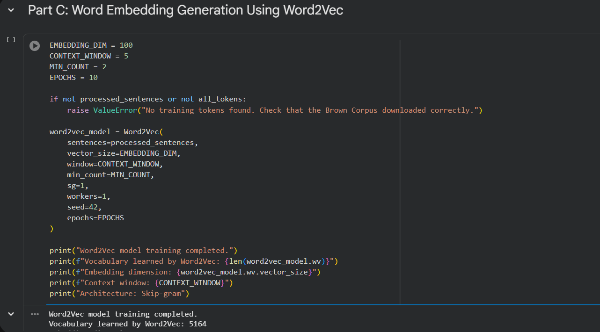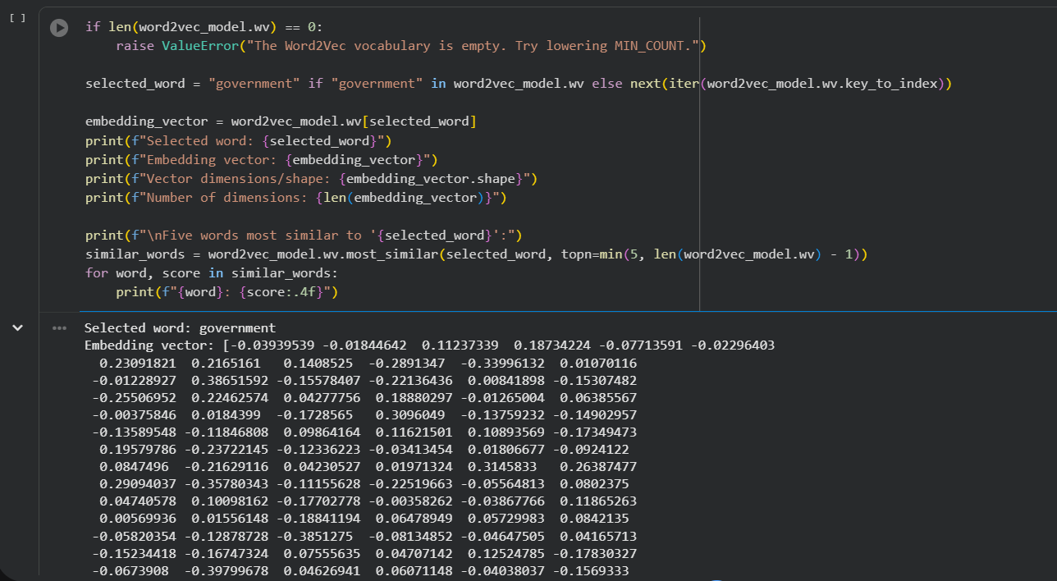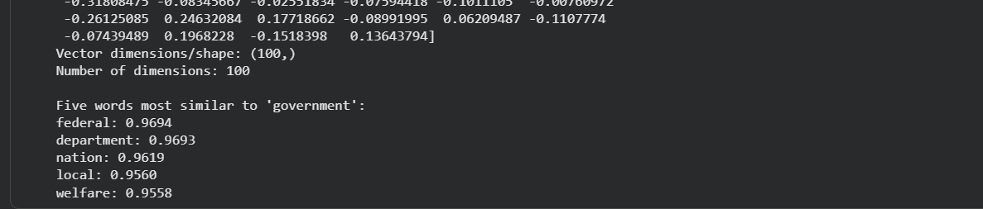

PART D: WORD SIMILARITY ANALYSIS AND EXPERIMENT MANAGEMENT
Perform the following tasks:
- Select three meaningful word pairs from the trained vocabulary.
- Calculate the cosine similarity between each pair using the Word2Vec model.
- Compare the similarity scores and identify the most similar pair.
- Analyze the relationship between contextual similarity and the generated word embeddings.
- Document the observations and upload the completed notebook to GitHub.
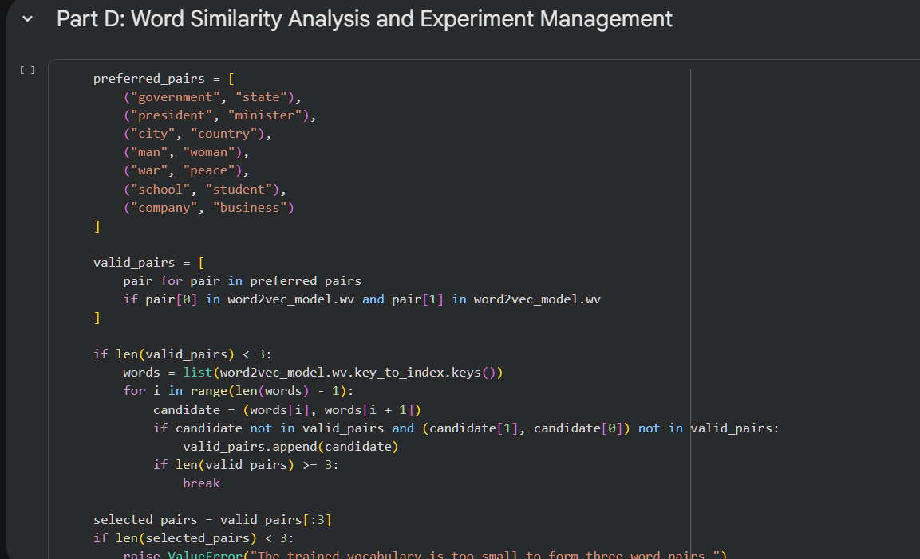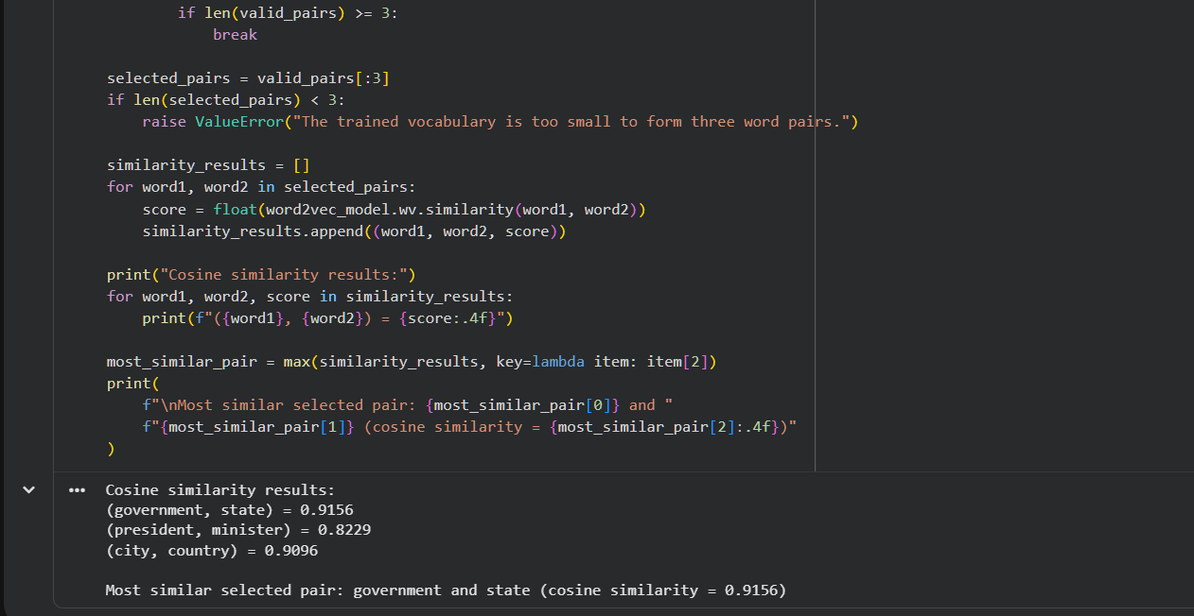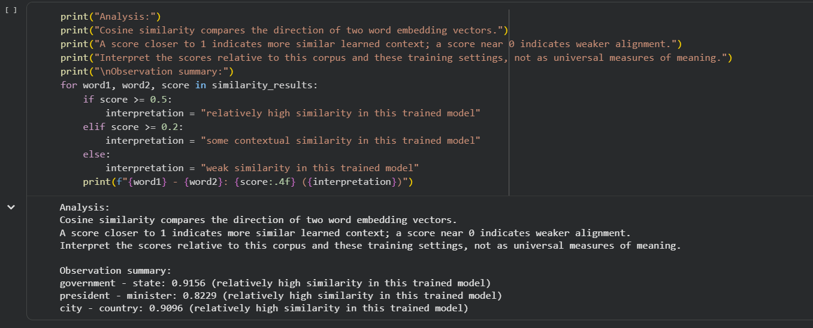

POST-LAB QUESTIONS

1. Analyze the effect of stop-word removal and lemmatization on the quality of preprocessed text.

Stop-word removal reduces unnecessary words and helps focus on the important terms in a document. It can reduce vocabulary size and improve computational efficiency during text processing. Lemmatization converts different forms of a word into their meaningful base form, such as “running” into “run.” This helps combine related words and improves consistency in the processed text. However, removing important stop words or applying incorrect lemmatization may cause the loss of useful contextual information.

2. Explain how vocabulary size influences Word2Vec training.

Vocabulary size refers to the number of unique words considered during Word2Vec training. A larger vocabulary can capture more words and semantic relationships but requires more memory and computational time. A smaller vocabulary reduces training complexity but may exclude rare yet meaningful words. Words that occur too infrequently may not have enough contextual information to learn reliable embeddings. Therefore, selecting an appropriate vocabulary size helps balance embedding quality, memory usage, and training efficiency.

3. Compare the CBOW and Skip-gram architectures of Word2Vec.

CBOW predicts a target word using its surrounding context words, whereas Skip-gram predicts surrounding words using a target word. CBOW is generally faster to train and works well with frequent words. Skip-gram often performs better for rare words because it learns from multiple context predictions. Both architectures generate dense word vectors that capture semantic relationships. The choice between them depends on the dataset size, word frequency distribution, and computational requirements.

4. Analyze how the context-window size affects the generated word embeddings.

The context-window size determines how many neighboring words are considered when learning word embeddings. A smaller window generally captures local syntactic relationships between nearby words. A larger window can capture broader semantic relationships by considering more distant words. However, an excessively large window may introduce less relevant contextual information and increase computational requirements. Choosing an appropriate window size helps Word2Vec learn meaningful word representations based on the characteristics of the dataset.

5. Interpret the cosine similarity scores obtained for the selected word pairs.

Cosine similarity measures the similarity between two word embedding vectors based on the angle between them. A score closer to 1 indicates that the words have highly similar vector representations, while a score near 0 indicates weak similarity. A score closer to -1 indicates that the vectors point in opposite directions, although negative scores are less common in many practical word embedding comparisons. The word pair with the highest cosine similarity is considered the most similar among the selected pairs. These scores help analyze semantic and contextual relationships learned by the Word2Vec model.

ASSESSMENT
Description | Max Marks | Marks Awarded
Pre Lab Exercise | 5
In Lab Exercise | 10
Post Lab Exercise | 5
Viva | 10
Total | 30
Faculty Signature

